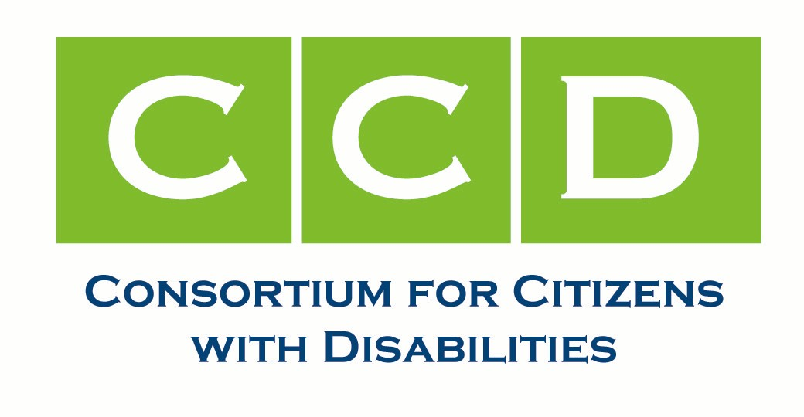
The House of Representatives introduced the American Healthcare Act on March 6, 2017.
If passed, this bill will have devastating effects on access to basic healthcare and Medicaid funded services and supports for America’s most vulnerable populations: children, people with disabilities, and low income Americans. The bill is moving through the House quickly and will reach the Senate soon. .
Join us to tell Congress that Medicaid cuts and caps are dangerous and unacceptable!

Social Media Toolkit #SaveMedicaid
Make your Voice Heard!
- Today: Sign up for our Thunderclap.
#ACA repeal bill caps Medicaid. Caps are cuts, and will have deadly consequences for people w/disabilities & seniors. #SaveMedicaid
On March 16 at 10am, let’s all tell Congress that Medicaid cuts and caps are dangerous and unacceptable. Sign up through the Thunderclap program, and it will automatically send this one message through your Twitter and/or Facebook accounts. Collectively the messages will spread across social media and slam the social feeds of your Members of Congress at once, like a virtual clap of thunder. If you have a Facebook or Twitter account, you can sign up for the Thunderclap <<LINK COMING>>. You must sign up by 8am on the 16th!
- Monday, March 13: Twitter Day of Action
‘No Cuts and Caps’ Day
Tweet and Facebook and call your Members of Congress telling them how harmful Medicaid cuts and caps will be. See sample tweets below and call (202) 224-3121 or (202) 456-1111.
- Tuesday, March 14: Twitter Day of Action
‘HCBS are Best’ Day
Tweet and Facebook and call your Members of Congress and share how important HCBS waivers and services are to you and your family. See sample tweets below.
- Wednesday, March 15: Twitter Day of Action
‘Impacted People’ Day
Tweet and Facebook and call your Members of Congress with stories of how cuts to Medicaid will have severe impacts to people with disabilities, seniors, children, and low-income Americans. See sample tweets below.
- Thursday, March 16: Thunderclap/Medicaid Call-In
The Thunderclap will go out at 10am today. Make sure you’ve signed up by 8am and share with your networks! Additionally, call your Members of Congress and tell them, “I need you to oppose the American Health Care Act because the caps on Medicaid funding will be extremely damaging to people with disabilities and many others. Please save Medicaid.” Use any of the sample tweets below as talking points. Continue to tweet and Facebook and email any of the below messages, especially if lines are busy or voicemail is full.
- Friday, March 17: Twitter Day of Action
‘Don’t Cut My Services’ Day
Tweet and Facebook and call your Member of Congress tell them not to cut services provided under Medicaid. See sample tweets below and call (202) 224-3121 or (202) 456-1111

Action Partners
@AUCDnews  @TheArcUS  @ACLU |  | Add in any other influential twitter users who will be committed to helping get the word out.

Action Partners
@ccd4pwd  @AUCDnews  @TheArcUS  @ACLU  @BazelonCenter  @autselfadvocacy  @NASDDDS  @LSA-DN |  | (Additional Twitter handles of partners and influential accounts will be posted here and updated throughout the week.)

Hashtags
Primary:  #SaveMedcaid | Secondary:  #MedicaidMatters  #KeepAmericaCovered  #CoverageMatters

Additional Resources
- Action Steps, Fact Sheets, Talking Points for protecting Medicaid and the ACA: http://www.c-c-d.org/rubriques.php?rubpage=42

- Sign up to stay informed with CCD: https://docs.google.com/forms/d/e/1FAIpQLSe-Nq62jgPeemGU9EqLHvIl9Hexa--xsDqOKIWwvtbzpITnDA/viewform.

Sample Tweets

Caps and Cuts are Devastating (Monday)
- Don’t be fooled: Caps ARE cuts. #SaveMedicaid #MedicaidMatters
- Per capital caps will shift $370Billion in costs to states over next 10yrs. @centeronbudget #SaveMedicaid
- Medicaid caps = Robin Hood in reverse. #SaveMedicaid
- ACA repeal means the US will “shed 2.6 million jobs in 2019, near 3 million by 2021.” @milkenInstitute #SaveMedicaid
- Timely access to care is a life or death matter. #SaveMedicaid
- States would get less federal funding than under current law, with the cuts growing each year. #SaveMedicaid
- Caps can’t keep up with cost increases, strangle future healthcare coverage for elderly & disabled who need it #SaveMedicaid #MedicaidMatters
- PWD rely on Medicaid. Funding caps and cuts will hurt them and their families the most. #SaveMedicaid
- Federal funding caps mean the rest of us will pay $$$ to keep same quality care #KeepAmericaCovered
- We need more Medicaid funding, not less, to improve choices and quality of care. #SaveMedicaid #MedicaidMatters
- Medicaid is my lifeline. #SaveMedicaid
- Caps = less funding. Less funding = fewer options #SaveMedicaid #MedicaidMatters
- Without federal funding, states will have to choose which people to cover and which to let die. #SaveMedicaid

HCBS are Best (Tuesday)
- Timely access to care is a life or death matter. #SaveMedicaid
- Medicaid cuts will end jobs for tens of thousands of direct care & support workers. #SaveMedicaid #SaveJobs
- Less funding = fewer options for people with disabilities and our families. #SaveMedicaid
- #HCBS waivers are hard to get as it is. Cutting funding will make the waitlists longer. #SaveMedicaid
- Living at home w/ supports is cheaper than living in a nursing home & more dignified. #SaveMedicaid #SaveOurDignity #HCBS
- Respite care shouldn’t be optional. #SaveMedicaid
- DYK schools get Medicaid $ for transportation and speech therapy? #SaveMedicaid
- Medicaid expands access to home- and community-based services. #SaveMedicaid #KeepAmericaCovered #HCBS

Impacted People (Wednesday)

Children
- We didn’t vote for health care reform at the expense of our children. #SaveMedicaid
- Medicaid is the nation’s largest health insurer for kids w/ disabilities & special health care needs, covering 43% of them #SaveMedicaid #SaveOurKids
- Slashing funds to state Medicaid prgms puts tax cuts for the wealthy ahead of children and their futures. #SaveMedicaid
- Nearly half of Medicaid beneficiaries are children: 30+million low-income kids rely on benefits to live. #SaveMedicaid
- Medicaid is currently the gold standard for children’s health care, including #EPSDT. Don’t force states to cut benefits. #SaveMedicaid
- Medicaid covers foster children and children with disabilities. #SaveMedicaid so these kids stay safe & healthy.
- Kids with disabilities should be in their own homes, not nursing homes. #SaveMedicaid
- Medicaid is the largest source of funding nationwide for maternity care. #SaveMedicaid

People with Disabilities
- We didn’t vote for health care reform at the expense of the most vulnerable. #SaveMedicaid
- Some #PWD need help to get up and out to work. #SaveMedicaid to save their independence and jobs
- What’s a “per capita cap” and what would it mean for me? @TuesdayWithLiz #SaveMedicaid https://www.youtube.com/watch?v=q0lXvND9nNM

Older Americans
- We didn’t vote for health care reform at the expense of the most vulnerable. #SaveMedicaid
- 1in7 seniors rely on Medicaid for care as they age. #SaveMedicaid
- Medicaid cuts and caps put our seniors in danger. #SaveMedicaid
- TrumpCare shreds the Medicaid safety net serving 72+million Americans. @familiesusa #SaveMedicaid

Loss of Services (Friday)
- We didn’t vote for health care reform at the expense of the most vulnerable. #SaveMedicaid
- Before the ACA, people with disabilities were routinely denied care, when they needed it the most. #KeepAmericaCovered #SaveMedicaid
- “Flexibility” shouldn’t mean fewer, lower quality options for people with disabilities and families #SaveMedicaid #MedicaidMatters
- The ACA gave millions of disabled Americans and their caregivers access to health insurance. #KeepAmericaCovered #SaveMedicaid
- #SaveMedicaid so people with disabilities & chronic conditions cab live healthy, independent, and fulfilling lives.
- Important services like speech therapy are currently covered. #SaveMedicaid #SaveOurServices
- Millions with mental or behavioral health conditions rely on Medicaid for needed services. #SaveMedicaid #KeepAmericaCovered
- Nobody should be denied access to quality healthcare #SaveMedicaid
- Do NOT allow restructuring and cuts to Medicaid to be part of an ACA replacement #SaveMedicaid

Graphics (more to follow!)
